CMPU2007 Databases 1 – Lab 1
In this assignment, you will start practising your knowledge of SQL and relational databases on a Windows laptop. To complete the lab, follow the instructions below on how to install PostgreSQL and DBeaver on your laptop.

How to install PostgreSQL on a Windows computer?
To install PostgreSQL on a Windows computer, follow the instructions below.
1. Visit the Postgres download website in your web browser.
2. Click on Download the installer and download the version suitable for
your Windows system (for example, Windows x86-64 Installer).
3. Save the file to a folder of your preference
4. Locate the downloaded installer and double-click on it to launch the installation wizard.
5. Follow the installation wizard's instructions. You might be prompted to set a password for the default PostgreSQL superuser account, called postgres. This password is required later to connect to your database through DBeaver. Make sure you remember this password, as there is no easy way to recover it! You can also leave it empty if you prefer.
6. During the installation, you may be asked to choose a port number. Keep the default port 5432.

How to install DBeaver on a Windows laptop?
To install DBeaver on a Windows laptop, follow the instructions below:
1. Visit the DBeaver website in your web browser.
2. On the left, you should see the downloads available for the DBeaver community edition – this is the free version of the software. Click on Windows (installer) to download it.
3. Locate the downloaded DBeaver installer and double-click on it to start the installation.
4. Follow the installation wizard's instructions. You can leave the settings as default for a basic installation.
5. Complete the installation by clicking Next and then Finish.
6. After the installation is complete, you can launch DBeaver from the Start menu or desktop shortcut.

How to connect PostgreSQL to DBeaver on a Windows computer?
PostgreSQL is where your database will be stored. DBeaver is the client side of the database, allowing you to manipulate it through code. For them to work together, they need to be connected. Connect your PostgreSQL database to DBeaver following the steps below:
1. Open PostgreSQL and click on Start.
2. Open DBeaver and click on Database -> New Database Connection. Select the PostgreSQL elephant icon and click Next.
3. In the Connection Settings, configure the following settings:

Host: localhost
Port: 5432 (default for PostgreSQL)
Database: postgres

User: postgres
Password: leave it empty if you did not create a password during PostgreSQL installation

4. Click the Test Connection button to ensure that DBeaver can connect to your PostgreSQL database.
5. If the test is successful, click Finish
6. In the main DBeaver window, you should see your PostgreSQL connection listed in the Database Navigator on the left. If you cannot see the Database Navigator, click on Window->Database Navigator.

Well done! Now you have installed PostgreSQL, DBeaver, and connected them.

Lab Instructions

Part A - Dataset analysis
The Science Foundation Ireland Gender Dashboard presents data on research award applications, considering the applicant’s gender and whether the research was funded or not. Download and analyse the dataset or take a look at a snapshot below:
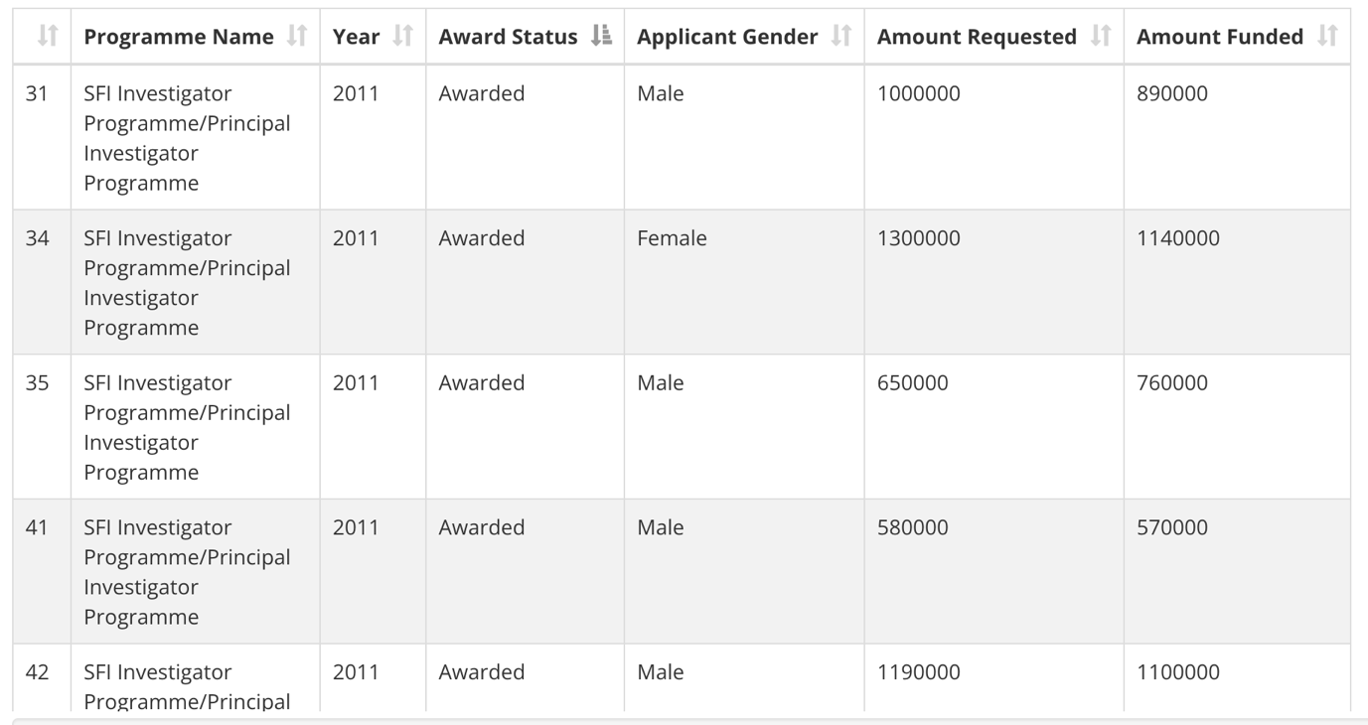

Consider the content covered during class and try to sketch a table to represent this dataset. Think of:
- The table’s name
- The columns’ names
- The columns’ data types
- The primary key (you can create a new column if none of the existing ones suit)

Part B - Creating a table using SQL
Open DBeaver, right-click on your database (named postgres) and select SQL Editor -> New SQL Script.
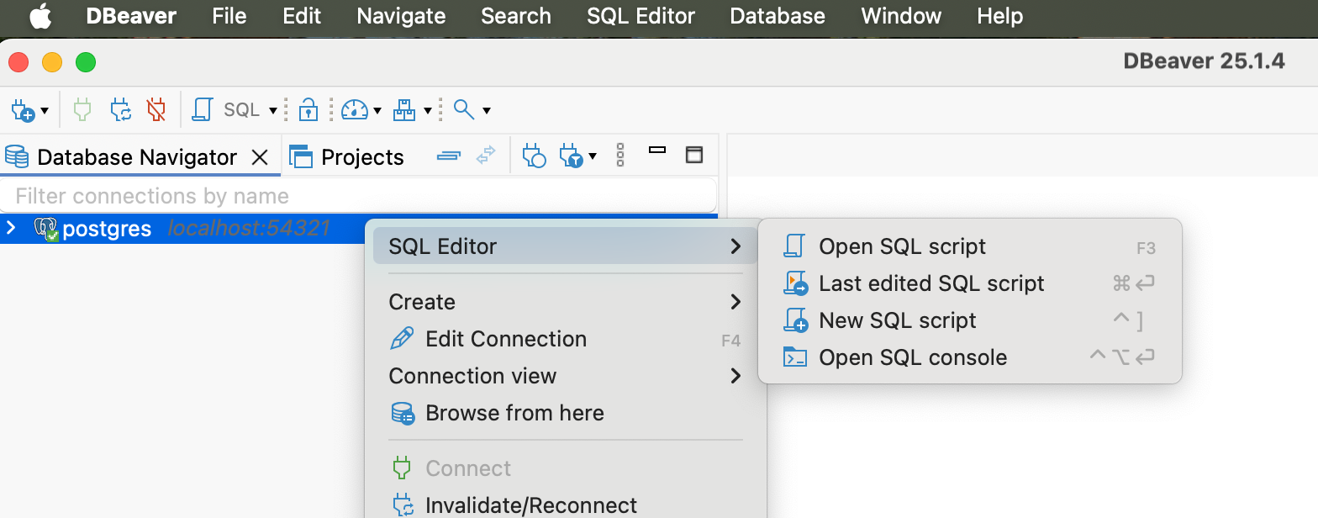

A window will open. Click on File -> Save as and save this file as lab1.sql. Modify lab1.sql to include the SQL code to create the table you sketched in part A. Make sure you drop the tables before creating them.
The PostgreSQL documentation can be helpful in this part of the assignment.

Part C – Running the code
To create the table, run the code by clicking on one of the three buttons:
 to run the selected line of code
 to run the selected line of code in a new tab
 to run the entire script

Part D - Populating the table
Considering the data presented in the original SFI dataset, insert 5 (five) rows into the table you created.
If you want to make sure everything went well, add a “select * from [name of your table]” to the end of your code to display the resulting populated table.

Submitting and demonstrating your lab assignment
- Submit the resulting SQL file to BrightSpace.
- Demonstrate and run your code on DBeaver to the lab assistant.

